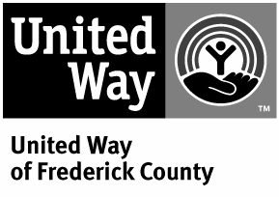

A Donor Bill of Rights

Philanthropy is based on voluntary action for the common good. It is a tradition of giving and sharing that is primary to the quality of life. To assure that philanthropy merits the respect and trust of the general public and that donors and prospective donors can have full confidence in United Way of Frederick County and its member agencies, we declare that all donors have these rights:

- To be informed of the organization’s mission, of the way the organization intends to use donated resources, and of its capacity to use donations effectively for there intended purposes.

- To be informed of the identity of those serving on the organization’s governing board, and to expect the board to exercise prudent judgment in its stewardship responsibilities.

- To have access to the organization’s most recent financial statements and financial information.

- To be assured their gifts will be used for the specific purposes for which they were intended and given.

- To receive appropriate and timely acknowledgement and recognition of their gifts.

- To be assured that information about their donations is handled with respect and with confidentiality to the extent provided by the law and in accordance with the donor’s wishes.

- To expect that all relationships with individuals representing the organization to the donor are professional in nature.

- To be informed whether those seeking donations are volunteers or employees of the organization.

- To have the opportunity for their names to be deleted from mailing lists and the assurance that mailing lists of individuals will not be shared with or sold to other organizations.

- To feel free to ask questions when making a donation and to receive prompt, forthright and truthful answers.

This document is based on the Donor’s Bill of Rights developed by the American Association of Fund-Raising Council that was endorsed by the Independent Sector and United Way of America. It has been modified to meet the needs and policies of United Way of Frederick County.



